PSP 4 FRAMEWORK INFORMATION - ANNEX B

SELECTION PROCEDURE

1. General – Applicable to Both Lots

1.1 Once the successful Suppliers are appointed to the Framework Agreement, secondary selection procedures are required to award specific Orders.

1.2 Suppliers are required to accept all Orders issued by Clients, except in exceptional circumstances. Continued failure to respond to orders may lead to disqualification of a Supplier from taking part in future selection procedures.

1.3 Suppliers who wish to reject the Order in accordance with 1.2, must provide a written explanation to the Client and Framework Client explaining why they are unable to fulfil the Order. This explanation must be provided within 48 hours of the proposed award, unless agreed by exception with the Client.

1.4 Instances of rejected Orders will form part of Supplier performance management including via the Framework Community Board.

1.5 Notwithstanding the selection procedures set out, and in accordance with the Key Principles set out in the Framework Information, MHA+ is committed to ensuring that the Framework promotes resilience and mitigates risks.

As such, the intention is that Suppliers will only be awarded Orders up to a specified amount in the aggregate over the Framework term. The amount will vary by Supplier and will be determined by the Framework Clients’ financial assessment of the Supplier. Financial assessments may be undertaken on a yearly basis, or more often at the Clients discretion, to determine the financial thresholds applicable.

2. LOT 1 Selection Procedures - Consultancy Services

2.1 There are six possible procedures the Client may use to award specific Orders in Lot 1:

1) direct award based on the overall ranking of Suppliers on the basis of their overall tender score (i.e. Quality and Price), prior to regional modifiers being applied to that score

2) regional direct award based on the ranking of Suppliers on the basis of their overall tender score for the Region in which the Client is based, including any regional modifiers to that score,

3) direct award based on the Client’s own price / quality weightings, as applied to the framework tender scores

4) direct award based on any of selection options 1-3, incorporating any Price discounts offered for delivery using Offshore Resources where this is offered by the Supplier and the Client permits delivery via these resources.

5) direct award based on any of options 1-4, and incorporating consideration of the ongoing performance of the Supplier.

6) mini competition involving all qualified Suppliers.

2.2 It is for the Client to decide the procedure used, selecting the option that they determine will provide the most economically advantageous tender (MEAT) for their requirements.

2.3 The application of the different award procedures are as follows:

Direct Award

1) Direct award based on overall ranking (Quality and Price)– the Client may award Time Charge or Work Orders directly to the top scoring Supplier based on their overall Quality and Price score at tender stage, excluding any changes to that score based on regional modifiers.

2) Regional direct award – the Client may award Orders directly to the top scoring Supplier based on their overall Quality and Price score at tender stage, including any changes to that score based on regional modifiers.

The sub-regions mirror those identified for the Medium Schemes Framework 4, as shown on the following map .

MHA+ Map

MHA+ sub-regional map 2022
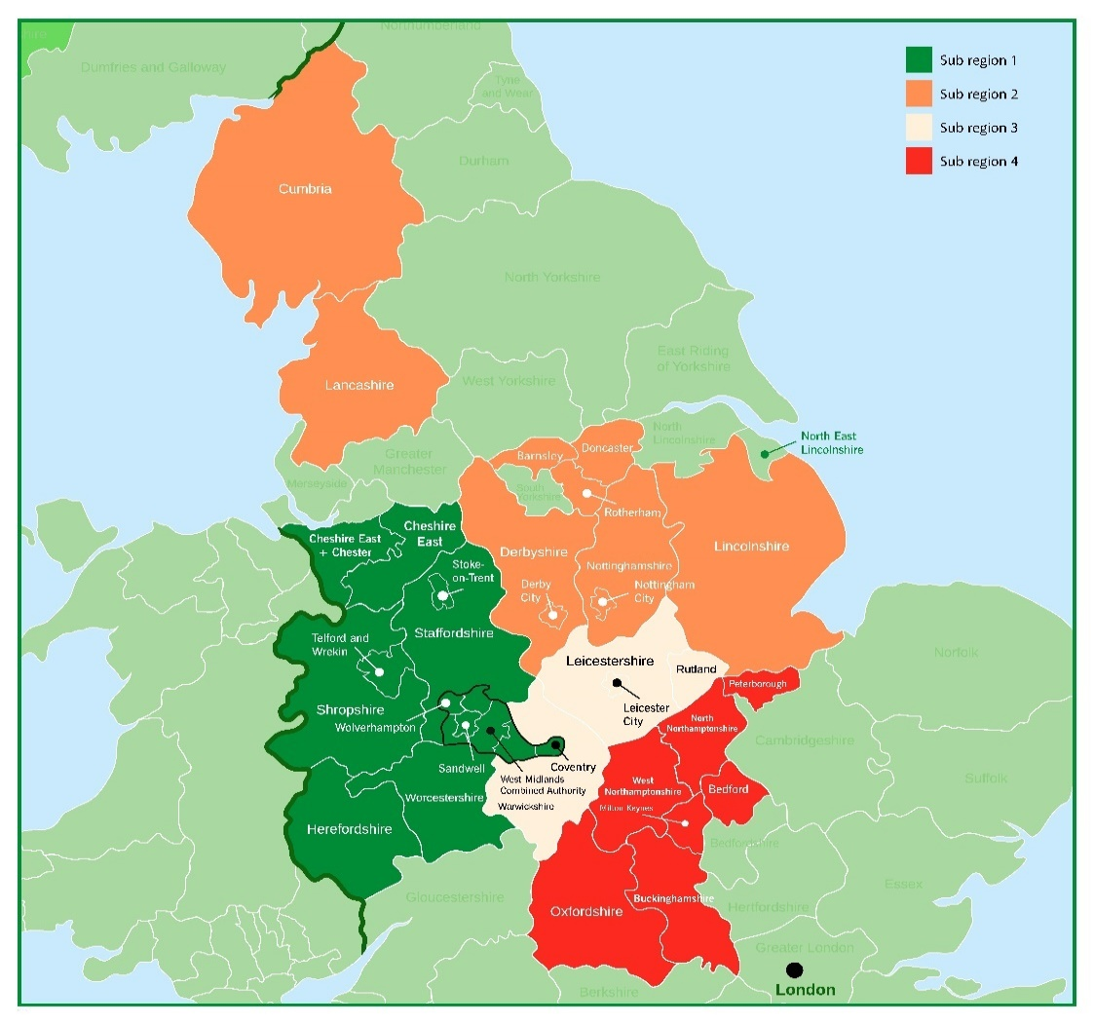

3) direct award based on the Client’s own price / quality weightings – The Client may award Orders to the Supplier who is the highest ranked based on the Clients’ own quality / price weightings as applied to the original framework tender scores (‘Client Adjusted Weighting’). The weightings applied by the Client may range from 0-100% on quality / price as follows:
Allowable Quality Weighting (range) | Allowable Price Weighting (range)
0% - 100% | 0% - 100%

A worked example of this process is provided below for information:

 | - Framework Tender Score (60% Quality / 40% Price) |  | - Client Adjusted Weighting to apply to direct award | - Direct award weighted scores based on Client Adjusted Weighting |  |  | Direct award ranking based on Client Adjusted Weighting
 | Quality | Price | B1. Quality: 80%  B2. Price: 20% | C1. Quality | C2. Price | C3. Total
Bidder A | 50  (83% of available quality) (A1) | 40  (100% of available price) = (A2) |  | 66.67  (A1*B1) | 20  (A2*B2) | 86.67  (C1+C2) | 2
Bidder B | 55  (92% of available quality) (A1) | 33  (83% of available price) (A2) |  | 73.33  (A1*B1) | 16.5  (A2*B2) | 89.83  (C1+C2) | 1
Bidder C | 45  (75% of available quality) (A1) | 30  (75% of available price) (A2) |  | 60  (A1*B1) | 15  (A2*B2) | 75.00  (C1+C2) | 3

4) direct award incorporating Offshore Resource discounts – The Client may award based on any of options 1-3, incorporating any Price discounts offered for delivery via Offshore Resources, where these discounts are offered by the Supplier and the Client will allow for this in their Order.

5) In addition, the Client reserves the right to incorporate consideration of the performance of the Supplier, as measured against the framework level Key Performance Indicators (KPI), in awarding Orders under the framework.

Supplier performance shall be taken account of as part of the Selection Procedure by way of an adjustment to a Supplier’s original tender Quality scores (Performance Adjustment). The Performance Adjustment may result in a Supplier’s Quality score increasing by 10%, or decreasing by 25%.

The Performance Adjustment amount will be updated on a quarterly basis using the rolling average from data collected.

The precise process under which performance shall be taken into account shall be communicated to Suppliers over the Framework term.

Mini-competition

2.4 The Client will issue to all Suppliers capable of performing the requirement a written notification of its intention to hold a mini-competition (‘Mini-Competition Invitation’) in respect of any quotation for a proposed Order.

2.5 The Suppliers will only be considered for that Order if they respond in full to the requirements of the Mini-Competition Invitation with all requested information completed (Mini-Tender response) by the deadline indicated therein, unless otherwise agreed by the Client.

2.6 The Client will determine the criteria (quality and price) that will be used to identify the most economically advantageous offer, and how that will be evaluated. The Client will inform the Suppliers in writing of these criteria within the Mini-Competition Invitation.

2.7 The Mini-Competition Invitation will set out the quality and price criteria and weightings against which the Client intends to evaluate the Mini-Tenders.

2.8 The Client must set out their Mini-Competition evaluation weighting within the following range:

Allowable Quality Weighting (range) | Allowable Price Weighting (range)
20% - 80% | 20% - 80%

2.9 The Mini-Competition Invitation will typically include an appropriate combination of the following:

a) The additional Contract Data Part 1, Scope and pricing document (activity schedule) giving details for the particular Order; as required by the quotation procedure.
b) Instructions including, for example, when and to whom the Mini-Tender has to be returned;
c) The weighting for price and the quality criteria against which the Mini-Tenders will be evaluated;
d) Details of how the quality criteria will be assessed – this may for instance include Order-specific delivery proposals;
e) Mini-Tenders must be in writing and must remain open for the period stated in the Mini-Competition Invitation. Suppliers must keep all contents of their Mini-Tenders confidential until the Mini-Tender return deadline has passed. The Client will not open Mini-Tenders until the return deadline has passed.

2.10 The Client will evaluate the Mini-Tenders received on the basis of the information set out in the Mini-Competition Invitation.

2.11 The Client may meet with the Suppliers or request further written information to clarify their proposals prior to finalising the evaluation scores.

2.12 The Supplier with the highest aggregate score (i.e. for price and quality) will be issued with an Instruction to carry out the Order.

2.13 The Supplier acknowledges and agrees that by submitting a Mini-Tender it is agreeing to be bound by the form of draft Contract issued by the Client within the Mini-Competition Invitation.

2.14 The Client may, in advance of issuing an Order, request input into the project requirements from a Supplier. The onus is on the Supplier to establish from the Client whether the request for input is to be undertaken as part of an Order, for which the Supplier shall be entitled to payment, or outside of the Order process, for which the Supplier shall not be entitled to payment.

2.15 The Client shall not be bound to enter into an Order following a mini-competition, and shall not be liable for any Supplier costs incurred in responding to the mini-competition.
LOT 2 Selection Procedures – Secondments

3.1 There are five possible procedures the Client may use to award specific Orders in Lot 2:

1) direct award based on the overall ranking of Suppliers on the basis of their overall tender score (quality and price combined);
2) direct award based on the Client’s own price / quality weightings, as applied to the framework tender scores;
3) direct award based on the unit Price for a specific job role;
4) direct award based on any of selection options 1-3, and incorporating consideration of the ongoing performance of the Supplier.
5) mini-competition

3.2 It is for the Client to decide the procedure used, selecting the option that they determine will provide the most economically advantageous tender (MEAT) for their requirements.

3.3 The application of the different award procedures are as follows:

Direct award

1) Direct award based on overall ranking (Quality and Price)– the Client may award Orders directly to the top scoring Supplier based on their overall Quality and Price score at tender stage.

2) Direct award based on the Client’s own price / quality weightings – The Client may award Orders to the Supplier who is the highest ranked based on the Clients’ own quality / price weightings as applied to the original framework tender scores (‘Client Adjusted Weighting’). The weightings applied by the Client may range from 0-100% on quality / price as follows:

Allowable Quality Weighting (range) | Allowable Price Weighting (range)
0% - 100% | 0% - 100%

A worked example of this process is provided below for information:

 | - Framework Tender Score (60% Quality / 40% Price) |  | - Client Adjusted Weighting to apply to direct award | - Direct award weighted scores based on Client Adjusted Weighting |  |  | Direct award ranking based on Client Adjusted Weighting
 | Quality | Price | B1. Quality: 80%  B2. Price: 20% | C1. Quality | C2. Price | C3. Total
Bidder A | 50  (83% of available quality) (A1) | 40  (100% of available price) = (A2) |  | 66.67  (A1*B1) | 20  (A2*B2) | 86.67  (C1+C2) | 2
Bidder B | 55  (92% of available quality) (A1) | 33  (83% of available price) (A2) |  | 73.33  (A1*B1) | 16.5  (A2*B2) | 89.83  (C1+C2) | 1
Bidder C | 45  (75% of available quality) (A1) | 30  (75% of available price) (A2) |  | 60  (A1*B1) | 15  (A2*B2) | 75.00  (C1+C2) | 3

3) Direct award based on the unit Price for a specific job role– The Client may award Orders to the Supplier with the lowest unit price for a specific job role by comparing the line item prices of both Suppliers for the specific specialism (eg Planner/Transport Planner) and Band (eg Band A) required.

4) In addition, the Client reserves the right to incorporate consideration of the performance of the Supplier, as measured against the framework level KPIs, in awarding Orders under the framework.

Supplier performance shall be taken account of as part of the Selection Procedure by way of an adjustment to a Supplier’s original tender Quality scores (Performance Adjustment). The Performance Adjustment may result in a Supplier’s Quality score increasing by 10%, or decreasing by 25%.

The Performance Adjustment amount will be updated on a quarterly basis using the rolling average from data collected.

The precise process under which performance shall be taken into account shall be communicated to Suppliers over the Framework term.
Mini competition:

3.4 The Client will issue to all Suppliers capable of performing the requirement a written notification of its intention to hold a mini-competition (‘Mini-Competition Invitation’) in respect of any quotation for a proposed Order.

3.5 The Suppliers will only be considered for that Order if they respond in full to the requirements of the Mini-Competition Invitation with all requested information completed by the deadline indicated therein, unless otherwise agreed by the Client.

3.6 The Client will determine the criteria (quality and price) that will be used to identify the most economically advantageous offer, and how that will be evaluated within the range set out at 3.8. The Client will inform the Suppliers in writing of these criteria in the Mini-Competition Invitation.

3.7 The default evaluation criteria (quality and price), to be applied unless stated otherwise in the Mini-Competition Invitation, will be 50% Quality / 50% Price, based on the CVs and Prices of the candidates proposed.

3.8 The Client may apply alternative quality and price weightings and criteria by exception, providing the weightings fall within the following range:

Allowable Quality Weighting (range) | Allowable Price Weighting (range)
20% - 80% | 20% - 80%

3.9 The Client will obtain quotations, including CVs and any other information requested, from both Suppliers in accordance with the quotation procedure at Annex C of the Framework Information.

3.10 The Client will consider the quotations received, evaluating and calculating the quality criteria as stated in the Mini-Competition Invitation, and evaluating the total of the quotation.

3.11 The Supplier with the highest aggregate score (i.e. for price and quality) will be eligible to be issued with an Instruction to carry out the Order.
3.12 The Client shall not be bound to enter into an Order following a mini-competition, and shall not be liable for any Supplier costs incurred in responding to the mini-competition.

