Carbon Management and Reduction in Highways Asset Management: Case Studies
Introduction
Within the Midlands Highway Alliance (MHA), a strategic decision has been made to take collaborative action across the Alliance to better understand, manage and reduce the carbon impact of highways asset management activities. To help achieve this, a series of resources have been developed to help guide authorities through the better management of carbon in their highway design, construction, maintenance and operational activities in a strategic, comprehensive, holistic and most importantly, sustainable manner and to facilitate multiple, wider benefits in doing so.
This document has been produced as part of the suite of resources, and provides real-life case study examples of how organisations have recently or are currently taking action with regards to carbon management and reduction. These case studies are designed to assist MHA authorities, their contractors and supply chains in identifying appropriate and effective action to take by providing real-life examples of replicable good practice and proven approaches and techniques.
The case studies in this document are divided into four categories: Materials; Street Lighting, Signalling and Signage; Techniques and Technologies; and Operational Delivery.
- Materials: including the use of low temperature asphalt, recycled/ reclaimed and other sustsinable materials.
- Street lighting, Signalling and Signage: including smart street lighting and asset review and reduction strategies
- Techniques and Technologies: including the use of heavy duty pavers and compaction technology
- Operational Delivery: including examples of effective collaboration, sustainability within the supply chain and carbon footprinting approaches.

Materials
Low energy materials – Lafarge Tarmac and Carbon Trust

On average, the UK produces around 25 million tonnes of asphalt per year; the carbon footprint of this production is estimated to be 786,000 tonnes of CO₂/year³. Low Temperature Asphalt (LTA) has the potential to reduce energy requirements and costs associated with production, and it is therefore estimated that it could cut the carbon emissions associated with asphalt production by up to 39% (when compared to conventional hot-mix asphalt). However, the use of LTA in the UK, so far, is limited. Between 2014 and 2017, Lafarge Tarmac and the Carbon Trust undertook research and trials with the objective of improving the carbon efficiency associated with the manufacture of road construction materials, with an aim of saving the UK highways sector £46.2m in energy costs and 260,000 tonnes of CO₂, between 2014 and 2024.

Specifically, the project sought to develop a new approach to LTA production and application. It aims to determine if it is a viable alternative to conventional hot-mix asphalts.

The research findings state that LTA offers the following benefits when compared to conventional hot-mix asphalt:
- Reduced energy consumption during production and application
- Reduced embodied carbon footprint
- Longer workability window during application
Figure 1: Recording the temperature of Low Temperature Asphalt (LTA)
- Allows for easier incorporation of recycled asphalt within mixes

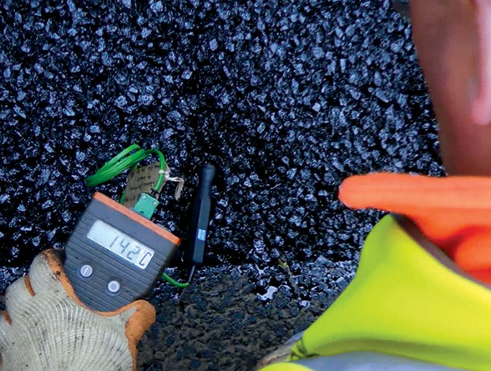
The research also identified a number of potential barriers to the use of LTA, these being:
- Lack of evidence of long-term performance
- Concerns regarding the higher capital cost of the material
- Absence of an official specification available for the use of LTA (at the time of the research)

Four materials were tested during the trial period:
- A LTA incorporating a cold-mix bitumen emulsion and recycled asphalt planings
- Three LTA half-warm mixes incorporating virgin aggregates and foamed bitumen

A 800m trial of the four materials was carried out in Leicester, where performance was assessed and compared between conventional hot-mix asphalt and the four half-warm and cold mixes. The ten mixes trialled are shown in Figure 2.

Figure 2: The ten mixes tested in the trial

The results showed that all mixes performed well, with the cold and half-warm mixes demonstrating stiffness comparable with the conventional hot-mix asphalts. The LTA mixes were also able to bond materials as effectively as the more conventional methods.

Some challenges were identified in regards to the use of foamed bitumen in the cold and half-warm mixes; this was due to in-situ water nozzles becoming blocked when switching from hot to semi-warm bitumen. The problem was overcome by adding already foamed bitumen into the mixer, and using larger spray nozzles that were less susceptible to blocking. This modification is easily adopted and costs in the region of £85,000 (one-off cost).

The results from the trial contributed to the development of the first specification for low temp asphalt mixtures in the UK.

Use of tar-bound planings in construction – Galliford Try

Contract/scheme – Muse Phases 2&3, Nottinghamshire
Date – 2017

The project involved planing off an existing runway that had been constructed using a tar-bound material. The material was contaminated, which led to the need to investigate sustainable options for its disposal or reuse. An objective was also by the client to minimise vehicle movements with regards to the transport of the planed materials away from the site, in order to reduce fuel use (and thereby emissions) and minimise Health & Safety risks.

Early engagement with the contractor identified an opportunity to re-use the tar-bound material on-site by using the planings within a new cement-bound layer. This resulted in significant cost savings through avoiding the transport and disposal of the planings, along with a reduction in the overall carbon footprint of the project, due to reduced fuel and energy use, and less reliance on new virgin materials.

The project demonstrates the need for careful planning and design management, and shows how collaborative working, particularly with the supply chain, can lead to enhanced sustainability of a project.
Use of pre-cast manhole systems – Galliford Try

Contract/scheme – A116 Rolls Royce Access and Muse Phases 2&3
Date – 2016

Traditional manhole construction is resource intensive and typically requires the delivery of ready-mix concrete to site.

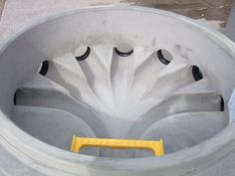
Figure 3: Pre-cast manhole.

Pre-cast manholes are an alternative to traditional manholes. Being pre-cast, there is no need for ready-mix concrete deliveries or re-entering a manhole at a later date to bench and/or re-seal the manhole. A pre-cast manhole is typically full installed in one day, compared to an average of three days for traditional manholes formed on-site. There is also less typically waste produced than when manholes are formed on-site. Although the pre-cast manholes have a somewhat higher capital cost, a reduction in construction time results in lower installation costs, and a lower embodied carbon footprint.

Evaluating carbon dioxide emissions from using enhanced levels of reclaimed asphalt in surfacing material –Transport Research Laboratory (TRL)

In 2010, TRL carried out a study into the use of reclaimed asphalt (RA) in surfacing materials as a way of reducing the whole-life energy requirements and carbon impacts of highway resurfacing activities. The research was undertaken as part of a resurfacing scheme on the M25 between Junctions 6 and 7.

A resurfacing material containing 40% RA was trialled against a standard resurfacing material comprised of 100% virgin aggregate. The RA material used was produced by Tarmac at the request of Mouchel, and involved reclaiming asphalt from the existing worn-out surface.

The use of the 40% RA material required some modification of batching plant equipment and material handling processes so that the higher-than-usual rate of recycled material could be accommodated.

An assessment of the whole-life energy requirements and carbon impact of the RA material was undertaken, based on the process set out in PAS 2050. The energy and carbon savings achieved through the use of the RA material (when compared to using 100% virgin aggregate mixes) are shown in Table 1.

Table 1: Summary of energy and carbon savings

The study focused on the carbon and energy requirement differences between virgin aggregate and reclaimed asphalt, rather than performance characteristics. Therefore, these results should be analyzed also against the virgin aggregate and reclaimed asphalt performance.
Sustainable Drainage Solution – Aggregate Industries

Aggregate Industries developed and trialled a new sustainable drainage product as part of their LifeTM range of solutions on a highways maintenance scheme in Shrewsbury (St. John’s Hill). This range of sustainable solutions meet the three following benchmarks (when compared to traditional highways maintenance materials):

Figure 4: Three benchmarks of the Life™ range of products
The sustainable drainage system used on this scheme incorporated half-warm mix technology, which meant it was able to be produced, transported and installed at lower temperatures. The product delivered significant carbon footprint reductions, while providing performance characteristics with regards to deformation resistance, stiffness and compactability that equalled typical hot-mix products.

Promoting the widespread use of VALORCOL – COLAS

VALORCOL is a cold-mix asphalt developed by COLAS, which consists of 100% reclaimed asphalt aggregate and a cold emulsion binder. VALORCOL has been used extensively in Switzerland as a sub-base and base course material, and, to a lesser degree, within surface courses. The thicknesses of the layers are comparable to traditional hot-rolled asphalt.

VALORCOL has a range of benefits in relation to both whole life financial and carbon savings, as follows:

Resource savings:
- The product contains 100% reclaimed asphalt, resulting in the saving of primary materials
- Reduced need for waste disposal

Transportation:
- Sources of reclaimed asphalt are usually closer to the scheme location than a quarry, reducing the transportation distance of materials.

Reduction in energy consumption and carbon emissions:
- The use of a cold-mix emulsion and reclaimed aggregates means that the energy consumption and carbon emissions associated with production and application are lower than traditional hot-mix materials using virgin materials.

A 12,000m² highway maintenance scheme in Jura, Switzerland, used 3,000 tonnes of VALORCOL in the pavement’s base course. Post construction analysis showed that energy and carbon savings of 48% were achieved, when compared to if more traditional materials had been used (transported hot bitumen and primary aggregates), as presented in Figure 5.

Figure 5: Comparing VALORCOL and initial asphalt solutions, with regards to energy consumption [MJ/m²] and greenhouse (GH) gas emissions in [CO₂e[kg/m²]].

Sheffield Private Funding Initiative (PFI); Delivering excellence in pavement solutions- Aggregate Industries

The Sheffield Private Funding Initiative (PFI) is a 25 year contract, allocating £2 billion to the improvement and maintenance of the Sheffield City Highway Network. The network and assets covered by the scope of the PFI includes:

- 1,900km of carriageway;
- 3,300km of footway;
- 68,000 street lights;
- 500 traffic lights;
- 18,000 items of street furniture;
- 12,700 name plates; and,
- 30,000 trees.

The overarching aim of the PFI is to bring the network up to the standard required to minimise the maintenance required in the final 20 years of the PFI.

The challenge associated is that a significant amount of the highway network contains tar-bound asphalt, which is a hazardous material when disturbed and therefore poses issues during disposal.

An initial proposal to deal with the tar-bound asphalt was to apply a high temperature recycling process to process the planings. Although this process was previously successful in Bedfordshire, it proved to be too slow and have a too high energy requirement to make it a feasible option (economically and environmentally) for Sheffield.

A series of alternative solutions were subsequently identified and proposed, these being:

- Foamix as a method to recycle the tar-bound planings by reusing the material as a binder course in highways and footways. Foamix is a cold recycled bound material, manufactured from recycled aggregates that are bound with foam produced by mixing atomised bitumen and water. This makes it a suitable alternative to bitumen emulsion, producing high strength pavement material. There are two types of Foamix:
  - Foamix heavy duty (QVE); suitable for heavily trafficked applications, specifically highways.
  - Foamix standard (SVE); suitable for footpaths and cycle paths; after mixing the material can be stored for up to 28 days.
- Cement Bound Mixtures (CBM) where planings are incorporated into a CBM using a mobile concrete batch plant.
- Any non-hazardous planings could be used as backfill material or within asphalt mixtures.

Quick Visco-Elastic (QVE) materials typically have stiffness equal to standard dense pavement material, and an equivalent life expectancy to dense asphalt construction.

Foamix, in particular, uses much lower temperatures during production and application than standard asphalt mixes, providing significant carbon savings. Recycled materials also provide additional environmental benefits, such as a reduced demand for virgin aggregates.

Asphalt Recycling

Asphalt recycling is common practice in the US; however, uptake in the UK has, so far, been limited. This is largely due to reluctance to use recycled asphalt material in the upper-most surface course of pavements, which traditionally uses virgin aggregate with high polished stone value (PSV) to provide the required skid resistance.

FM Conway, in partnership with Transport for London, trialed the use of recycled asphalt material in the surface course on the A1 at Mill Hill. This trial has so far proved very successful, with early indicators showing that skid resistance provided by the material is consistent, with high levels of PSV. As such, FM Conway proceeded to lay an asphalt surface course containing 50% high PSV recycled aggregate on the A40.

Street lighting, Signalling and Signage
New traffic lights to help reduce carbon footprint – Lincolnshire County Council

Lincolnshire County Council has recently been undergoing a transition to low energy LED light systems across both traffic lights and street lighting, in an attempt to reduce the council’s carbon footprint and to achieve whole-life cost savings. At the time of writing, approximately a third of the county’s lighting had been upgraded to LED technology.

The new LED light systems are expected to be six times more energy efficient than conventional street lighting options, with the potential to achieve carbon reductions of 300 tonnes per year, and energy savings of £60,000 per year.

Funding for the project is from the Lincolnshire County Council’s Salix fund, which is designated to improve energy efficiency and is matched by government funding through the Carbon Trust.

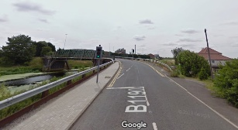
Figure 6: Updated LED traffic lights on Bardney Bridge, Lincolnshire (Google Maps)

Highways Asset Review and Reduction Programme – Derbyshire County Council

Derbyshire County Council’s Highways Asset Review and Reduction Programme (HARRP) was created to minimise the impact of the highway network (specifically road signs) on Derbyshire's natural landscapes, heritage and townscapes. It is believed that too many signs and road markings can also reduce the effectiveness of important road safety messages by making it harder for road users to identify and process the messages. The HARRP also has the objective of identifying opportunities to reduce the environmental impact of sign production, installation and operation.

As part of the HARRP, Derbyshire County Council is reviewing traffic sign provision in certain areas of the county to determine whether any existing signage can be deemed as unnecessary and therefore removed. At the time of case study development, 75 traffic signs and 40 posts have been removed in Dronfield, North East Derbyshire. In terms of lighting provision, unnecessary lighting at traffic signs causes light pollution, drives up energy costs and generates carbon emissions. Between 2012 and 2013, lighting was removed from 344 signs across Derbyshire, accumulating to an estimated saving of 31 tonnes of carbon per year.

Smart streetlighting
IoTUK commissioned a report to look into the future of street lighting and the potential for new technology development. The report highlights that the switch to LED lighting alone may not be enough to meet energy consumption and reduction targets, and they propose that the low-energy progression of street lighting needs to follow three stages:
- Stage 1 – Switch to LED bulbs
- Stage 2 – Connected street lighting
- Stage 3 – New service development
Connected street lighting can provide greater means of control over lighting assets; for example, by allowing operators to change light levels based on local conditions, and incorporating motion sensors to switch lights on when cars or pedestrians are in the vicinity. Central Management Systems (CMS) can be used to remotely and intelligently manage lighting, connected via wireless internet connections, radio frequency, GPRS, 3G etc.
The proposed third stage moves beyond just the lighting bulb and considers applications and opportunities for the whole lighting column. Lighting columns can act as a conduit for other ‘smart’ applications through the integration of data collection devices, such as sensors and cameras. Figure 7 provides an overview of the potential applications for lamppost lighting column.
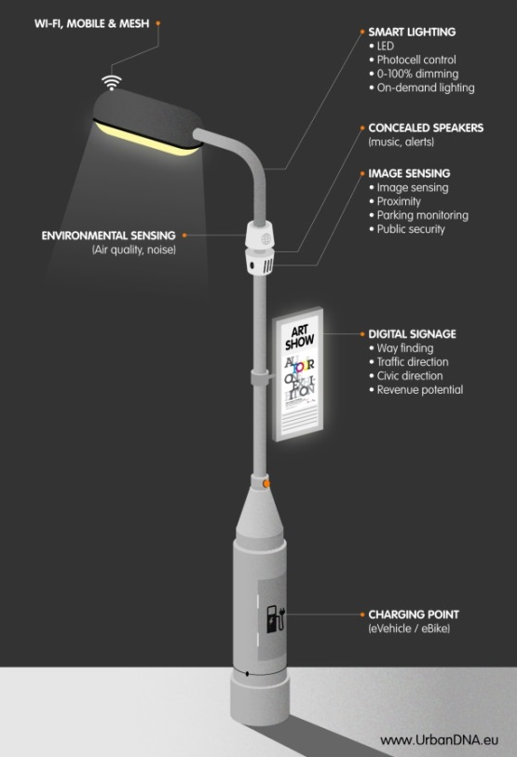
Figure 7: Applications for the modern lamppost

Techniques and Technologies
A465 Dualling from Brynmawr to Tredegar - Carillion

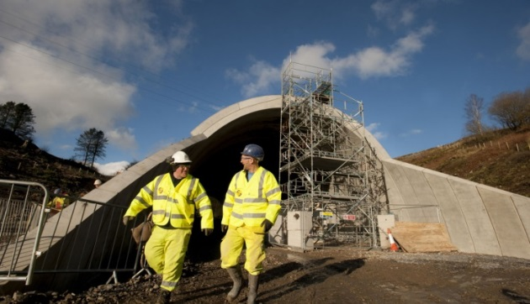
Figure 8: Dual-carriage-way, from Brynmawr to Tredgar.
A 7.8km dual carriageway was constructed through a valley and mountain landscape to create an important link between the Midlands and South-West Wales.

A pre-construction whole-life carbon assessment identified opportunities to achieve a 10% reduction in construction carbon footprint. Steelwork, concrete and bituminous surfacing accounted for 80% of construction carbon in the scheme, and therefore these areas in particular were identified as areas in which significant carbon savings could be made.

Furthermore, a significant amount of carbon is generated during the in-use life of a road. Bearing this in mind, the road was designed to make it as carbon efficient as possible for road users. An estimated 18,404 tonnes of carbon over the first 15 years of the road’s lifetime was saved by replacing a planned viaduct with an embankment. Grade-separated junctions also led to a reduction in in-use carbon.

Furthermore, 2,000 tonnes of carbon was saved during the construction phase by using ECO welfare units (environmentally efficient site accommodation), hydrogen generators, an ePOD (electronic Proof Of Delivery) small plant distribution container and LED lighting.

Other additional good practice included the construction site access road being recycled to form part of the permanent cycle track. There was also the promotion of car sharing within the project team, which resulted in a saving of 1,334kg CO₂ during construction.
Low Carbon Innovative solutions

The following case studies from Aggregate Industries present how smaller-scale interventions and solutions can lead to carbon saving benefits.

Figure 9: Eco Countryside Cycle Kerb
The Eco Countryside Cycle Kerb, which safely segregates cyclists from passing traffic, is able to withstand vehicular impact and replicates the aesthetics of natural granite. It can also be laid in one unit, which is quicker than many traditional solutions. The product comprises 82% recycled and secondary material content, and results in a 33% carbon reduction compared to the imported natural granite often used in kerbs.

Non-tipping trucks
Aggregate Industries have been investing in new trucks that use a walking floor discharge system. The trucks allow for a greater load capacity which reduces carbon emissions due to fewer vehicle movements. The trucks also offer improved worker safety, and a flexible solution for space-restrictive projects.

Titan ABG heavy duty pavers
Aggregate Industries have pavers capable of laying cementitious and asphalt mixtures up to 13m wide and 300mm thick in single layer. This means they are able to lay two full dual carriageway lane widths in one pass removing joints normally associated with the use of two standard machines. The machines reduce health and safety risks associated with two machines working in close proximity and help to keep costs and a scheme’s carbon footprint to a minimum.
The Internet of Things (IoT)
The IoT has been discussed for decades however, with the recent surge in connected devices its application in the real world is starting to take shape. Simply put, the IoT is about connecting devices over the internet allowing them to communicate with each other and with humans. An example of this is smart meters, which can be connected to devices and subsequently allow the user to remotely heating within their homes and monito energy use over a period of time.
There are numerous opportunities to use the IoT to reduce the carbon impact of highway network operation and maintenance. For instance, by installing cameras and sensors on street furniture, the availability of parking spaces can be communicated to connected drivers through resulting in less congestion and vehicle idling whilst waiting and looking for an available space, and improved local air quality. See Figure 10 for more details. Exeter City Council and Devon County Council are also currently deploying IoT sensors on lighting columns to measure and monitor real-time traffic and weather data in order to ease congestion and reduce emissions.
Figure 10: Application of IoT to ease city centre congestion

Creating new methods and materials for 21st century roads – Eurovia Vinci

Eurovia Vinci has developed a series of methods and materials to help reduce the environmental impact of construction projects. These are summarised below.

Figure 11:- Use of RECYCLOCIA® and TEMPERA®

GAIA
GAIA is an environmental decision-making tool that can be used to evaluating the environmental impact of different material solutions for roadworks projects. The tool provides environmental criterion to support decision-making, which includes greenhouse gas emissions and resource efficiency.

RECYCLOCIA®
RECYCLOCIA® is an in-situ pavement recycling process using a cold bituminous binder and an emulsion or foamed bitumen. It can be used as flexible and semi-ridged pavement surfacing amounting to carbon savings of 20-40%, when compared to conventional methods and materials.

TEMPERA©
TEMPERA© is a range of warm mix asphalts produced and laid at temperatures 30˚C to 50˚C below conventional asphalt mixes. Reducing mixing and application temperature reduces the quantity of fuel needed to heat the materials in the mix plant. In situ performance of these materials is quoted to be equal to conventional hot-mix asphalt materials.

A556 Knutsford to Bowden Improvement- Aggregate Industries

The A556 is a major trunk road between North Cheshire and South Manchester. The Knutsford to Bowden Improvement scheme involved improvements to a 4.5 mile stretch where the single lane carriageway was replaced with a dual two-lane carriageway with additional improvements made to Junction 7 of the M56.

The scheme involved composite pavement design combining a Cement Bound Granular Mixture (CBGM) sub-base with a flexible asphalt pavement. A mobile batching plant was established to produce the CBGM and foamed asphalt on site. The foamed asphalt used recycled tar-bound planings from the site.

The site had poor underlying ground condition comprising poorly drained silty-sand. The composite pavement reduced the overall depth of construction and this combined with the use of recycled aggregate within the mix, resulted in carbon savings when compared to conventional methods where only primary virgin materials are used.

A new paver model was used; Vogele Super 1803-3i. The paver uses a tier-4 diesel engine with AdBlue®, which works with the catalytic converter to minimise harmful diesel emissions using Selective Catalytic Reduction.
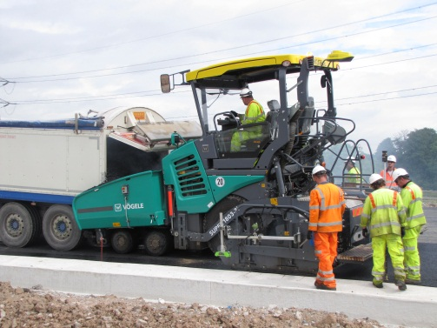

Figure 12: Vogele Super 1803-3i working on the A556 Knutsford to Bowden Improvement

Operational Delivery
Partnerships that drive Excellence: Tarmac, Costain and Lancashire County Council

Construction of the Heysham – M6 link road in Lancashire demonstrates how collaboration between the client and its contractors can deliver carbon and financial savings across the lifetime of a project. Tarmac was the single supplier of ready-mix concrete, aggregates and asphalt, and Costain was the main contractor.

Key Performance Indicators (KPIs) were established and agreed to be used across both contractor organisations to drive project efficiencies and performance. Tarmac and Costain both participated in this voluntary initiative to demonstrate their commitment to carbon reduction, demonstrating best practice and setting a precedent for other organisations and projects of this type.

The KPIs were determined during the early stages of the project in order to maximise sustainability achievements such as minimising the number of part-filled truck movements. A timely identification of KPIs also provided with opportunities for sustainability innovation.

A Carbon Calculator was used to monitor and measure the carbon impact of all elements of the project from quarrying of raw materials to on site plant use. The Carbon Calculator and the use of KPIs identified that it would be more efficient, in terms of fuel use and carbon emissions, to deliver materials to site in large articulated lorries rather than eight wheel trucks.

A logistics plan was also created to identify the optimal routes to site for materials thereby minimising the impact of the project on local traffic and reducing vehicle mileage and fuel use. This included the use of twitter to inform local communities of heavy vehicle movements.

Finally, a new mix design was developed at the Early Contractor Involvement (ECI) stage which reduced aggregate tonnage by 25% and reduced the use of ready-mix concrete by 26%. This resulted in a 21% CO₂ saving, exceeding the KPI of a 20% reduction.

Carbon Footprint Calculator – Tarmac

As the UK moves towards a low carbon economy, the government has set targets for the construction industry to reduce its greenhouse emissions by 50% by 2025. Tarmac’s Carbon Footprint Calculator, developed in line with the requirements of PAS 2050, takes a whole-life approach to carbon calculation and allows for the identification of solutions that can provide carbon reduction benefits.

The Carbon Footprint Calculator involves calculating the embodied emissions of a range of materials and products thereby providing customers with information on the carbon impact of the products they are purchasing to identify lower carbon alternatives.
The calculator is flexible as it can provide with the embodied carbon footprint of a single product or a whole scheme.

asPECT Carbon Calculator

The asPECT Carbon Calculator provides a standardised method to measure the whole-life carbon impact of highway construction products with a focus on asphalt materials.
The tool was developed by Highways England, the Mineral Products Association, the Refined Bitumen Association and TRL Ltd.
The Excel-based calculator uses user inputs alongside embedded carbon emission factors and calculations to produce carbon footprint figures.
Figure 13 presents the life-cycle stages used within the aspect tool.
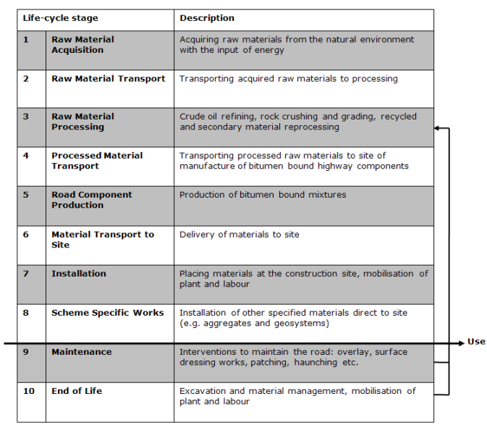
Figure 13: Key life cycle stages of highway’s products, as defined in the asPECT Carbon Calculator

The International Road Federation (IRF) Greenhouse Gas Calculator - CHANGER

The IRF has designed a methodology for calculating and modelling carbon emission estimates for road construction and maintenance. The CHANGER calculator involves calculating CO₂ and other Greenhouse Gas emissions through the use of a robust, structured and accessible inventory system. Figure 15 presents the structure of the CHANGER tool.
Figure 14: Structure of the IRF Greenhouse Gas Calculator (CHANGER).

The tool:

- Produces a detailed environmental analysis of road projects;
- Sets the stage for comparative analysis of various road-building techniques and materials;
- Optimises road construction site supply characteristics, raw material providers, choice of suppliers, delivery locations and materials transport modes; and,
- Develops an estimation of the emissions associated with a project.

The calculator is compatible with Intergovernmental Panel on Climate Change (IPCC) guidelines and emission factor standards.

The calculator outputs provide an incentive for innovation and improvement of current construction practices. It also helps to identify energy intensive practices which would benefit by being replaced by more energy-efficient techniques and technologies.
A1 Leeming to Barton (A1L2B): Delivering Excellence with Pride- Aggregate Industries

A Carillion / Morgan Sindal JV secured the contract for the upgrade of the A1 from Leeming to Barton. Aggregate Industries were appointed as a partner for material supply.

The project involved upgrading the existing dual carriageway, which carries over 60,000 vehicles a day, to a new three-lane motorway. A new local access road, a new grade separated junction at Catterick and an improved junction at Scotch Corner was also required.

To reduce heavy vehicle movements on the network during the construction phase, mitigate conflicts with local communities, minimise the scheme’s carbon footprint and meet the extensive aggregate requirements, Aggregate Industries mobilised one of their eight Mobile Cementitious Mixing Plants at Barton where aggregates were stockpiled to meet the demands of the project.

Carbon Trust. (2014). Low Temperature Asphalt: Case Study . http://www.carbontrust.com/media/506150/cts398-low-temperature-asphalt-tarmac-case-study.pdf. [Accessed 09/08/17].
The Carbon Trust. (2014). Lafarge Tarmac and Carbon Trust launch low energy road building materials with potential to save industry £46m. [Online]. Available at: https://www.carbontrust.com/news/2014/01/lafarge-tarmac-carbon-trust-launch-low-energy-road-building-materials/. [Accessed 09/08/17].
J C Nicholls, H Bailey, N Ghazireh, and D H Day (2013). Specification for Low Temperature Asphalt Mixtures. [Online] Available at: https://trl.co.uk/reports/PPR666 (accessed 15 November 2017)
Information provided directly by Galliford Try
Information provided directly by Galliford Try
Transport Research Laboratory.(2010). Enhanced levels of reclaimed asphalt in surfacing materials: A case study evaluating carbon dioxide emissions. [Online], Available at: https://trl.co.uk/reports/PPR468. [Accessed 09/08/17]
PAS 2050:2011 Specification for the assessment of the life cycle greenhouse gas emissions of goods and services. Available at: https://shop.bsigroup.com/forms/PASs/PAS-2050/ [Accessed 03/01/2018]
Aggregate Industries. (2013). Highways and infrastructure solutions. [Online]. Available at: https://www.aggregate.com/documents/brochures/highways-sector-guide-aggregate-industries-b.pdf. [Accessed 15/08/17].
International Road Federation. (date). Innovative Practices for Greener Roads. [Online]. Available at: https://www.irfnet.ch/files-upload/pdf-files/IRF_BP_Environment_Web.pdf. [Accessed 15/08/17].
Direct from Aggregate Industries
Infrastructure Intelligence (2016). nnovative asphalt ramping up recycling. [Online]. Available at: http://www.infrastructure-intelligence.com/article/apr-2016/innovative-asphalt-ramping-recycling [Accessed 27/03/18]
Lincolnshire County Council. (2016). New traffic lights on Bardney Bridge will help reduce carbon footprint. [Online]. Available at: https://www.lincolnshire.gov.uk/news/new-traffic-lights-on-bardney-bridge-will-help-reduce-carbon-footprint/129859.article. [Accessed 08/08/17].
Derbyshire County Council Highways asset review and reduction programme (HARRP). Available at: https://www.derbyshire.gov.uk/transport_roads/roads_traffic/harrp/default.asp [Accessed 03/01/2018]
Derbyshire County Council. (Date). Highways asset review and reduction programme. [Online]. Available at: https://www.derbyshire.gov.uk/transport_roads/roads_traffic/harrp/default.asp. [Accessed 08/08/17].
iot UK. 2017. The future of street lighting, the potential for new service development [Online]. Accessed from: https://iotuk.org.uk/wp-content/uploads/2017/04/The-Future-of-Street-Lighting.pdf [Accessed 21/11/2017]
Carillion. (Date). A465 dualling from Brynmawr to Tredegar – a road to regeneration. [Online]. Available at: https://www.carillionplc.com/news-and-media/a465-dualling-from-brynmawr-to-tredegar-a-road-to-regeneration/. [Accessed 08/08/17]
Exemplar. (Date). A465 dualling - Brynmawr to Tredegar. [Online]. Available at: http://www.cewales.org.uk/files/5514/7739/1657/Website_Version_-_CE_A465_4pp_EXEMPLAR_-_Design_Stage_Web.pdf. [Accessed 16/08/17]
Aggregate Industries. (2015). Sustainability Report. [Online]. Available at: http://www.aggregate.com/pagefiles/6765/sustainability-report-2015.pdf. [Accessed 15/08/17].
IoTUK. 2017. The future of street lighting, the potential for new service development [Online]. Accessed at: https://iotuk.org.uk/wp-content/uploads/2017/04/The-Future-of-Street-Lighting.pdf [Accessed 21/11/2017]
IoTUK. 2017. The future of street lighting, the potential for new service development [Online]. Accessed at: https://iotuk.org.uk/wp-content/uploads/2017/04/The-Future-of-Street-Lighting.pdf [Accessed 21/11/2017]
International Road Federation. (date). Innovative Practices for Greener Roads. [Online]. Available at: https://www.irfnet.ch/files-upload/pdf-files/IRF_BP_Environment_Web.pdf. [Accessed 15/08/17].
Eurovia Vinci. . Warm Mix Product Range – TEMPERA. Available at: http://www.eurovia.com/media/129485/tempera_a4_gb_bd.pdf [Accessed 01/03/18]
Direct from Aggregate Industries
Tarmac. (2016). Partnership drives excellence; Infrastructure report 2016 [Accessed 09/08/17].
Tarmac. (Date). Carbon Footprint Calculator. http://www.tarmac.com/sustainability/carbon-footprint/. [Accessed 09/08/17].
AsPECT. Project overview. http://www.sustainabilityofhighways.org.uk/Overview.aspx
International Road Federation. (date). Innovative Practices for Greener Roads. [Online]. Available at: https://www.irfnet.ch/files-upload/pdf-files/IRF_BP_Environment_Web.pdf. [Accessed 15/08/17].
Information provided by Aggregate Industries

