Midlands Highway Alliance Guidance for Developing a Carbon Management and Reduction Business Case
The purpose of this document is to assist Midlands Highway Alliance (MHA) member authorities in developing business cases for taking action to more effectively understand, manage and reduce the carbon impact of highway projects, and for communicating the importance of better carbon management to senior managers and decision-makers. This document includes guidance on identifying the opportunities and benefits of effective highways carbon management.
This document is supported by a Sustainable Supply Chain Protocol (see the Appendix). This Protocol acts as guidance for the MHA and its contractors and suppliers in facilitating, ensuring and enhancing sustainability within the supply chain. The Sustainable Supply Chain Protocol can also be used in isolation depending upon user requirements. Links to further information are embedded within this document where relevant.
An accompanying case study document provides examples of successful action taken to effectively understand, manage and reduce the carbon impact of highway asset management activities that can be reviewed and used when developing a business case for action.

Overview: Developing a Business Case
The diagram below outlines the steps to be taken when developing a business case, and recommendations for what to include within each step. More details on each step are provided after the diagram.

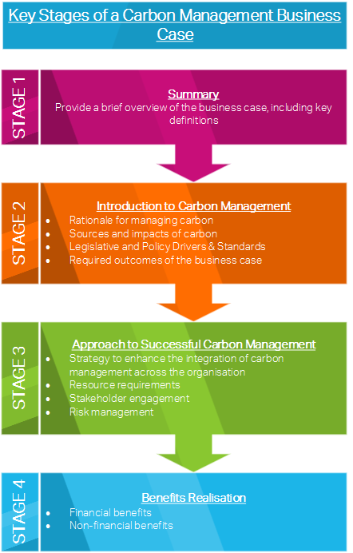

The guidance provided below includes examples of content that could be included in a business case. These examples are for guidance purposes only and should be adapted to better suit individual circumstances and requirements.

STAGE 1: Summary
TOP TIP
Keep language relevant, avoid using jargon.
Key Definitions
When developing a business case, any unclear or unfamiliar terms should be defined upfront to avoid any confusion and uncertainty. Examples may include.
- Operational Carbon:
Emissions associated with the operation and maintenance of an asset.
- Embodied Carbon:
Carbon integrated in the product as a result of extraction and processing of the raw material to make the final product.
- Whole-life Carbon:
Combination of all the carbon produced in the life of a product up to disposal.

Provide a brief overview of the business case
The ‘Summary’ section of a business case should equip senior managers and decision-makers with the overarching context relating to the need for the effective management and reduction of carbon as well as the background and drivers behind the development and need for a business case. Important points to cover here include:
- Reasons to better manage carbon:
  - Short rationale, summarising the impact of carbon emissions on the global and local climate, and the impacts of poor carbon management on the organisations (cost implications, reputational risks etc.) – see Box 1 for more information.
- Current position of the organisation in regards to carbon management:
  - Outline what the organisation is currently doing with regards to carbon management and reduction, and why (if relevant) this needs to be improved upon.
- Overview of the proposal:
  - Identify what area of carbon management and/ or reduction needs attention and investment, and provide a succinct overview of the proposed approach.
- Expected outcomes of the proposed action(s):
  - A brief overview of the key results and benefits (financial and non-financial).
- Plan for implementation and benefits realisation:
  - Summary of next steps, monitoring requirements and estimates for when the benefits are likely to be realised.

BOX 1: Climate Change Impacts

The impact of greenhouse gas emissions from human activities on the global climate is unprecedented. Projections for changes to the global climate from the Intergovernmental Panel on Climate Change (IPCC) indicate that the world will continue to warm, with greater seasonality and more frequent occurrences of severe weather events. To help minimise the magnitude of these changes, emissions must be reduced.
At the local level, a recent assessment of the potential impacts of climate change on the MHA’s highway networks, assets and operations identified that drier and hotter summers, wetter winters, and an increase in the frequency of heavy rainfall events and other severe weather types will result in increased deterioration and damage to assets, health and safety risks, and an increased need for maintenance and repair. Sea level rise will also make any highway networks and assets located in coastal areas at an increased risk of flooding, damage and coastal erosion.

STAGE 2: Introduction to Carbon Management
Discuss the purpose and drivers behind the business case
To begin to develop the key aspects of a business case, the following four components should ideally be established.
- Carbon impacts and opportunities
A good starting point is the identification of organisation-specific operations and services that produce carbon emissions and the areas where the biggest opportunities to reduce carbon lie. For example:
The UK has a legally-binding agreement to reduce its carbon emissions by 80% by 2050, an estimated 53% of UK carbon emissions are from the infrastructure sector. Infrastructure assets, network and projects have carbon implications across their entire lifecycles and supply chains, from the extraction and processing of primary materials through to disposal and reuse.
For highway authorities, highway design, construction, operation and maintenance offer numerous opportunities for taking action to better manage and reduce the whole-life carbon impact of assets and networks.
- Rationale for reducing carbon
Better management and reduction of carbon in highway design, construction, operation and maintenance can lead to financial savings, reputational benefits, and a more collaborative and innovative sector. Furthermore:
- It is becoming widely recognised that a better understanding of operational and embodied carbon emissions is needed to realise the true carbon impacts of new and existing infrastructure projects.
- Since 2000, the real cost of resources has risen by ~150% due to increased demand, fewer new reserves and increased cost of extraction and processing, thereby making it increasingly important to better manage resources, increase the lifetime for assets and increase reuse and recycling rates.
- Industry stakeholders generally agree that there is a high chance that the measurement, management and reduction of embodied carbon in construction projects could soon become a mandatory requirement in the UK.

- Policy drivers and relevant standards
There are an increasing number of policy drivers and legislative requirements driving the need for better carbon management and reduction across the infrastructure sector.
Relevant policies, legislation and standards include PAS 2080 , the Infrastructure Carbon Review, Construction 2025, and the Climate Change Act. These policies and standards are led by the overarching UK target to reduce carbon emissions by 80% by 2050, compared to 1990 levels. These should be referenced within any business case to demonstrate how the proposed action(s) will help to achieve and comply with the requirements. Other wider standards may also be of interest and therefore worth referring to in a business case, such as the EU Green Public Procurement Criteria for Road Design, Construction and Maintenance, which aims to help public authorities purchase products, services and works with reduced environmental impacts.
- Identification of required outcomes of the business case
The required outcomes from a business case typically include buy-in and agreement from senior managers and decision-makers (financially and from a technical feasibility/ commercial viability point of view) to support the proposed approach(es) to carbon management and reduction.

STAGE 3: Approach to Successful Carbon Management and Reduction
Once the drivers and objectives are clear, the proposed approach(es) should be robustly presented
This section of a business case should outline the proposed approach(es) to managing and reducing carbon, detailing what the approach(es) will involve and what opportunities and risks are likely or possible. The business case should clearly determine the timescales, resource and financial requirements, and the people/ teams/ departments/ organisations to be responsible and/ or involved in its development and implementation.
Prior to presenting a business case, there is a need to understand any stakeholder requirements to ensure the proposed approach is in line with these requirements, and thereby maximising the probability of agreement and success. Stakeholders may include the staff involved in the development and implementation of the approach, any involved supply chain organisations and community groups that may be affected during development or implementation. It is also recommended to gain the backing of an influential sponsor connected (if possible) to the relevant decision-makers or senior managers, to further strengthen the business case and help identify any additional risks and opportunities.
In terms of the requirements for implementation, the business case should typically and as a minimum include details on:
- Financial requirements, risks and benefits:
  - Capital and whole-life costs
  - Requirements for external investment or funding
  - Return on investment and operational saving opportunities
- Non-financial requirements:
  - Policy, standard, system or specification changes required to support and facilitate implementation
  - Resource requirements (people)
  - Training requirements

STAGE 4: Benefits Realisation
Once the approach has been presented, the business case should outline the potential benefits
Emphasising the benefits of taking action helps to ensure buy-in. Financial and non-financial benefits should be set out and quantified wherever possible. Reference should also be made to how the proposed approach aligns with and will help to meet the requirements of wider organisational strategic objectives or plans.
Emphasising the risks of inaction is another useful way to get people on board with a strategy.
Benefits discussed and quantified (where possible) may include:
- Financial benefits;
  - Compelling financial return and rapid payback time
  - Improved efficiency in processes leading to improved financial performance
  - Increased operational and process efficiency, leading to reduced energy consumption and reduced labour costs
  - Increased resilience to energy and resource price rises and resource scarcity risks
- Non-financial benefits:
  - Reduced waste and increased recycling and reuse rates
  - Less reliance on primary and increasingly scarce raw materials
  - Competitive advantage and reputational benefits
  - Increased collaboration across the sector and supply chains

The following checklist can be used when developing a business plan:

Checklist for building your business case
Clarify key terms and definitions
Provide brief / high-level overview of the business case
Outline the key carbon impacts and opportunities for reduction
Outline the rationale for reducing carbon
Outline the policy drivers and any relevant standards
Identify the required outcomes of the business case
Present the proposed approach(es), including timescales
Outline the potential financial and non-financial requirements and dependencies associated with development and implementation
Outline the potential financial and non-financial benefits
Outline the potential risks of inaction
Outline stakeholder needs and engagement requirements
Outline how the approach(es) align with and help to meet the requirements of wider objectives, plans and policies
Other…

For more advice on how to create a business case see:
  - Carbon Trust - Making the Business Case for a Carbon Reduction Project .

Appendix: Sustainable Supply Chain Protocol

Introduction and Background
The Sustainable Supply Chain Protocol contains information on the following:
- Summary of what a sustainable supply chain protocol entails, defining sustainability and sustainable procurement;
- Reasons why enhanced sustainability is important within any supply chain;
- The benefits of incorporating sustainability in the supply chain and;
- Key principles.
MHA authorities can use this protocol as a guide for incorporating sustainability into procurement decision-making. It can also enable and assist suppliers and contractors when seeking to demonstrate their sustainability credentials.
By enhancing sustainability across the MHA and its contractors and supply chain, environmental, economic, social and reputational benefits can be realised and collaboration and innovation can be encouraged.

BOX 2: Sustainable Procurement Defined

Sustainable development involves meeting the needs of the present without compromising the ability of future generations to meet their own needs. Sustainability is comprised of three elements; social, economic and environmental. Sustainable procurement may be defined as purchasing that determines the best value by accounting for social, environmental and economic issues. Furthermore, ISO 20400 defines sustainable procurement as ‘procurement that has the most positive environmental, social and economic impacts across the entire life cycle, striving to minimise adverse impacts.’ To achieve a sustainable supply chain, operations must function within an accurate financial structure, coupled with contributing societal value and therefore, accounting for relevant economic, social and environmental issues, not in isolation.

The Importance of a Sustainable Supply Chain
Becoming sustainable and resilient is increasingly important for organisations, particularly with the increasing threat of a changing climate and the rising costs of resources and energy.
Sustainability should and can be considered and embedded at any stage of a project. However, the earlier sustainability is considered in a project, the more opportunity there is for the most significant sustainability benefits to be identified and realised, as shown for carbon reduction in Figure 1.
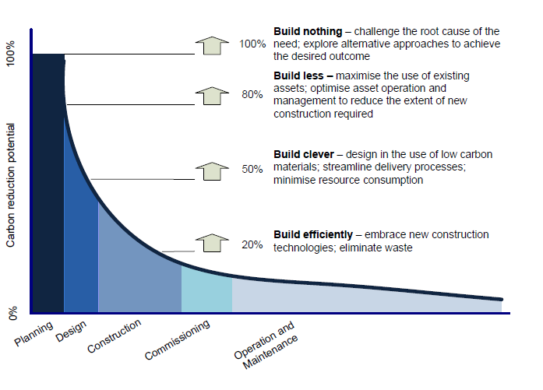
Figure 1: Carbon reduction opportunity curve
There is also an increasing public and political pressure on organisations to deliver societal benefits as part of their investments and activities. This drives the need for organisations to, amongst other things, have a robust Environmental Management System (EMS) in place and to actively demonstrate how they are working to enhance the environmental and social domain of local areas and communities.

The Benefits of a Sustainable Supply Chain

The benefits of increased sustainability within supply chains include robust services and operations, enhanced collaboration, improved efficiency, reduced whole life-costs and reduced operational and reputational risks. For a supplier, demonstrating sustainability leads to competitive advantage and facilitate a cascade effect, where other organisations are also encouraged to be more sustainable.
Demanding sustainability within the supply chain and applying sustainable procurement processes not only benefits the environment, but also the long-term viability of the entire supply chain. In a world where an organisation’s reputation is becoming strongly linked to their environmental and societal impact, it is also important for suppliers to engage with sustainable procurement principles. Sustainable procurement also drives forward innovation and collaboration, leading to wider benefits realisation. Further information on EMS requirements and benefits are provided in subsequent sections.

Key Principles of Sustainable Procurement
The diagram below presents a lifecycle approach to integrating sustainability into each step of the procurement process, as set out in ISO 20400.
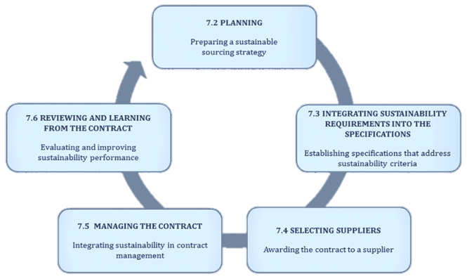
Figure 2: Integrating sustainability into the procurement process (taken from ISO 20400)

Assessing sustainability
When assessing the sustainability of an organisation, the following elements should be sought and assessed, where available.
- Environmental Management Systems (EMS)
Contractor and suppliers should preferably have their own EMS. An EMS includes the identification of the environmental impacts of an organisation’s normal operations. There are multiple ways for organisations to develop and implement an EMS. Obtaining a formal ISO 14001 and ISO 20400 certification, or EMAS registration, demonstrates formal commitment to reduce environmental impact across the organisation. Some organisations choose to follow and comply with the ISO 14001 guidelines without seeking formal certification. Alternatively, implementation of the requirements set out in BS 8555 can be more appropriate for small to medium sized organisations (SMEs), which do not have the resources available to fully implement and gain certification against ISO 14001.
Figure 3 outlines the key components of a typical EMS. Having such a structure and process in places demonstrates an organisation’s commitment to environmental management and sustainability.
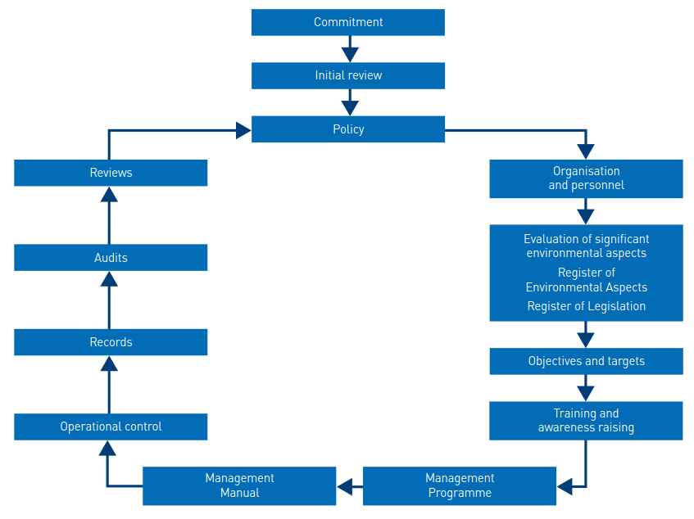
Figure 3- Elements of a typical Environmental Management System.

- Dedicated staff and resources
Having staff (with the appropriate qualifications, experience and levels of training) and resources dedicated to environmental management and sustainability demonstrates commitment to embed and ensure robust environmental management and sustainability within an organisation and its activities and operations.
- Good practice procedures in place
Contractors and suppliers should be able to demonstrate that they have procedures and processes in place for considering, embedding, measuring and monitoring environmental performance and sustainability within their activities and operations. Apart from environmental impacts, contractors and suppliers should ideally be able to demonstrate a commitment to enhancing and protecting social sustainability. This may be through community engagement and investment, generating local employment opportunities, participation in community and charitable initiatives, and engaging with Small and Medium-Sized Enterprises (SMEs).
- Collaboration and innovation
ISO 20400 highlights the importance of innovation and collaboration in the supply chain and their role in helping to ensure productivity and transparency.
Innovation can lead to the development of new products and markets, while collaboration can promote sharing knowledge and best practice. Both innovation and collaborative require commitment from the client and the supplier as well as the involvement of wider stakeholder groups.
- Sustainable materials and Life Cycle Analysis (LCA)
Contractors and suppliers should also ideally be able to demonstrate whole-life and lifecycle approaches to assessing the impacts of activities and products. Adopting a lifecycle approach allows for impact ‘hotspots’ to be identified and addressed effectively. For material suppliers in particular, compliance with ISO 14040:2006 (Environmental management -- Life cycle assessment) and/ or PAS 2050:2011 (Specification for the assessment of the life cycle greenhouse gas emissions of goods and services) also demonstrates a commitment to understanding and managing the whole-life impact of products and services.
BOX 3: Lifecycle Assessment

Lifecycle impacts should ideally be considered when sourcing and procuring materials and services. Full Lifecycle Assessment (LCA) of products or services will not be possible or feasible in many cases as the necessary information and resources will not be available. However, being aware of the environmental impacts of a service or product and showing a commitment to reducing these impacts should be demonstrated by all suppliers.
There are a range of tools and guidance available to help calculate the carbon impact of highway materials across their lifecycle, such as the asPECT Carbon Calculator and the International Road Federation Greenhouse Gas Calculator.

Figure 4 displays a simplification of the product lifecycle for asphalt. There are environmental impacts associated with each stage.

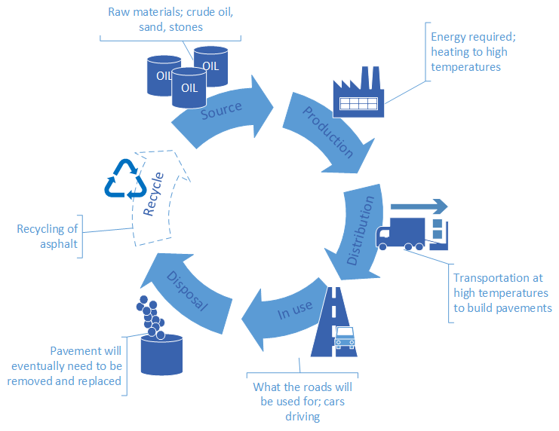
Figure 4: Simplified Life Cycle of Asphalt

HM Treasury (2013). Infrastructure Carbon Review. Available at: https://www.gov.uk/government/publications/infrastructure-carbon-review. [Accessed 14/11/17].
IPCC. (2014). https://www.ipcc.ch/report/ar5/syr/. [Accessed 11/08/17].
AECOM. (2014). Midlands Highway Alliance- Climate change adaptation guidance and good practice (2014) http://www.mhaweb.org.uk/download/climate_change/MHA_CCAReport_Final_Nov15.pdf [Accessed 11/08/17].
HM Treasury (2013). Infrastructure Carbon Review. Available at: https://www.gov.uk/government/publications/infrastructure-carbon-review. [Accessed 14/11/17].
IPCC. (2014). Industry chapter. https://www.ipcc.ch/pdf/assessment-report/ar5/wg3/ipcc_wg3_ar5_chapter10.pdf. [Accessed 11/08/17].
WRAP (2014). Opportunities to take action on resource efficiency in refurbishment and fit-out projects (REF104-101). Available at: http://www.wrap.org.uk/node/19617. [Accessed 14/11/17].
HM Treasury (2013). Infrastructure Carbon Review. Available at: https://www.gov.uk/government/publications/infrastructure-carbon-review. [Accessed 14/11/17]
European Commission. (2016). EU Green Public Procurement Criteria for Road Design, Construction and Maintenance. Available at: http://ec.europa.eu/environment/gpp/pdf/GPP%20criteria%20Roads%20(2016)%20203.pdf. [Accessed 6/11/2017].
Brundtland. (1987). Our Common Future. World Commission on Environment and Development
iema. (Date). Sustainable procurement seminar; Sustainable Procurement Explored. https://www.iema.net/event-reports/2016/09/29/sustainable-procurement-explored/. [Accessed 02/08/2017]
ISO. (2017). ISO 20400:2017, Sustainable Procurement. Available at: https://www.iso.org/standard/63026.html. [Accessed 20/11/2017].
Cuthbertson, R. et. al. (2011). Sustainable Supply Chain Management; Practical Ideas for Moving Towards Best Practice. Springer: Berlin, Heidelberg.
HM Treasury (2012). Infrastructure Carbon Review. https://www.gov.uk/government/publications/infrastructure-carbon-review
WRAP. (Date). Guide to Environmental Management Systems. http://www.wrap.org.uk/content/your-guide-environmental-management-systems-ems. [Accessed 02/08/2017]
Highways England. (2009). Procurement Strategy; Delivering sustainable value through supply chain management. http://assets.highways.gov.uk/about-us/corporate-documents-procurement-strategy/Procurement_Strategy_2009-10.pdf. [Accessed 02/08/2017]
ISO. (2017). ISO 20400:2017, Sustainable Procurement. Available at: https://www.iso.org/standard/63026.html. [Accessed 20/11/2017].
ISO. (2017). ISO 20400:2017, Sustainable Procurement. Available at: https://www.iso.org/standard/63026.html. [Accessed 20/11/2017].
ISO (2015). ISO 14001:2015 - Environmental management systems, Requirements with guidance for use. Available at: https://www.iso.org/iso-14001-environmental-management.html [Accessed 02/01/2018]
BSI (2003). BS 8555: Environmental management Systems - Guide to the phased implementation of an environmental management system including the use of environmental performance evaluation. Available at: https://shop.bsigroup.com/ProductDetail?pid=000000000030339300 [Accessed 03/01/2018)
WRAP. Guide to Environmental Management Systems. http://www.wrap.org.uk/content/your-guide-environmental-management-systems-ems.
ISO. (2017). ISO 20400:2017, Sustainable Procurement. Available at: https://www.iso.org/standard/63026.html. [Accessed 20/11/2017].
ISO. (2016). ISO 14040:2006 Environmental Management; Life cycle assessment; Principles and framework. Available at: https://www.iso.org/standard/37456.html. [Accessed 20/11/2017].
BSI. (2011). PAS 2050:2011. Available at: https://shop.bsigroup.com/Browse-By-Subject/Environmental-Management-and-Sustainability/PAS-2050/. [Accessed 20/11/2017].
WRAP. http://www.wrap.org.uk/content/supply-chain-management-and-sustainable-procurement-guide-scottish-smes
AsPECT. Project overview. http://www.sustainabilityofhighways.org.uk/Overview.aspx. [Accessed 15/08/17].
International Road Federation. (date). Innovative Practices for Greener Roads. [Online]. Available at: https://www.irfnet.ch/files-upload/pdf-files/IRF_BP_Environment_Web.pdf. [Accessed 15/08/17].

